Milestone 3

2017

- Team Name:

Hello 215

- Team Members Name and NSID

Name: Yinsheng Dong (yid164)
Name: Hao Li (hal356)
Name: Zhihao Lin (zhl798)
Name: Jinyang Liu (jil167)
Name: Yanzhao Lu(yal121)

- Project Name

Student Information Record System.

- Project Description
This is a student information system using MIPS assembly. When a new student registered for the class, an array will be created to store information of the student, including the student’s name, student number, and grades. There is also a method which represents information about all students in a specific course. The recording system will remove students’ information once they withdraw from the course. In addition, there is also a function which allows you to calculate the class average. The main goal of our application is to be able to store and manage student information easily and correctly.

- Project Design

This is our flow chart:
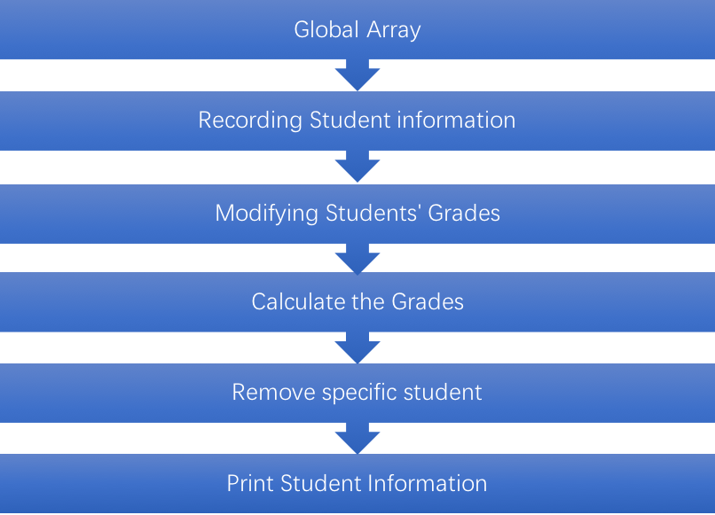

- Global array: Save all student information, such as Student Name, Student ID, student grades
- Recording Student Information: Allows users to enter student Name, to create new student file in Array, with unique student ID, and initialize the grade for this student. Each student has 4 assignments grades, and 1 exam grade. Modifying student’s grades: users can modify/update grades by searching student ID, we will try to do this part by iterator functions.
- Calculate the grade: Users can calculate the final grade of student by searching student ID.
- Remove student: Users are able to remove an existing student.
- Print Student’s information: User can either print all students’ information, or print one specific student by searching his/her ID. The printed information includes student name, student ID, assignment grades, exam grades, and final grades

We will use 16-bit graphic display in our project, Our mock design:
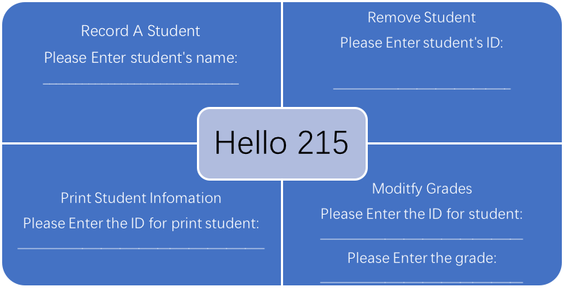
We will try to do this, but the real thing will be slightly different.

- Project Goal

July 16: Decide functions in the system and give explanation. (Completed)
July 19: List data and variables. (Completed)
July 24: Implement functions for student information recording. (Completed)
July 30: Implement functions for grade recording and calculation. (Not completed)
August 2: Testing and debugging. (Testing and debugging for the current version are done).
August 7: Discuss parts of the program that can be improved.
August 14: Complete the final version.
August 14: Complete final report.

- ReadMe
This program is written in MIPS Assembly. Please read the following instructions:
- Download the IDE(Mars) for MIPS Assembly at http://courses.missouristate.edu/KenVollmar/mars/
- After installation, run the IDE.
- Click open and select the file of the program:
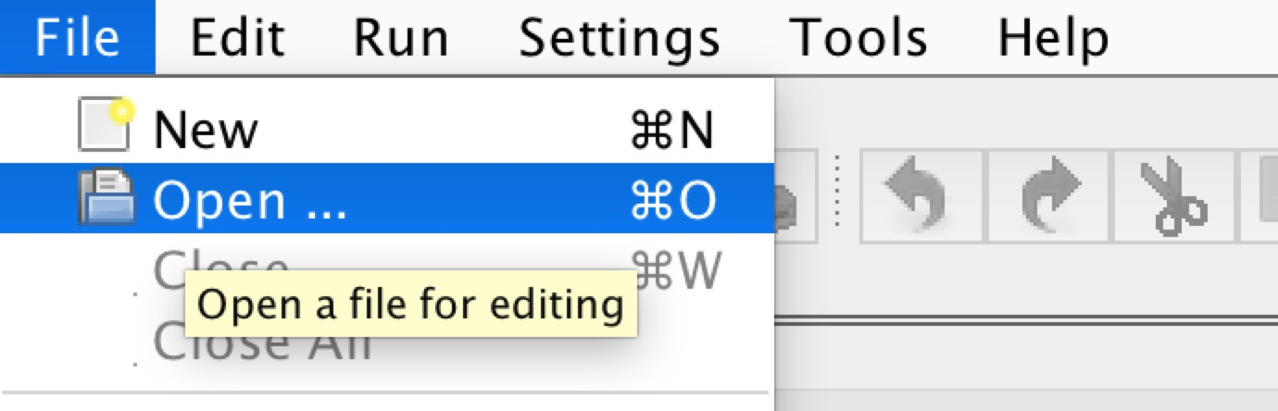
- Assemble the file by clicking the left-most button on the following graph:
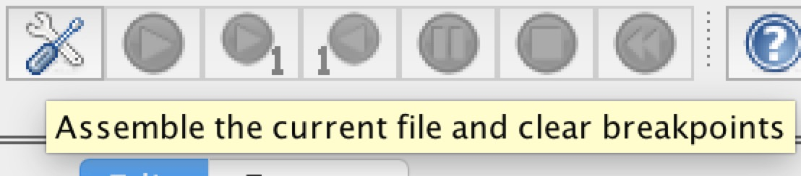

- Run the program by clicking the button:

- There are two options for you to choose:
- Press 1 to create a new student file.
- Press 2 to remove an existing student file.

8.Sample Output
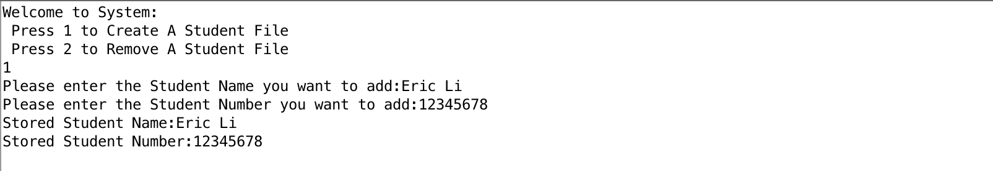

9.SVN log: https://svn.cs.usask.ca/svn/student/215/hello215/
